DIGITAL ASSIGNMENT

# KMEANS CLUSTERING

NAME SIDHANTHA PODDAR ROLLNO 17BCE2044

In [103]: 

**%**matplotlib inline

**from** copy **import** deepcopy **import** numpy **as** np **import** pandas **as** pd

**from** matplotlib **import** pyplot **as** plt

In [2]: 

data **=** pd.read_csv('East+Midlands.csv') print(data.shape)

data.head()

(23677, 26) Out[2]:

**Year CP Estimation_method Estimation_method_detailed Region LocalAuthority Roa**

1. 2000 6004 Counted Manual count East Midlands
2. 2000 6005 Counted Manual count East Midlands
3. 2000 6006 Counted Manual count East Midlands
4. 2000 6043 Counted Manual count East Midlands

Northamptonshire M Leicestershire M

Derbyshire M

Northamptonshire M4

1. 2000 6082 Estimated Estimated using previous

year's AADF on this link

East Midlands

Rutland A

1. rows × 26 columns

**import** numpy **as** np

**import** matplotlib.pyplot **as** plt

**from** mpl_toolkits.mplot3d **import** Axes3D

**from** sklearn.cluster **import** KMeans

**from** sklearn.datasets **import** make_blobs

plt.rcParams['figure.figsize'] **=** (10,8)

X**=**data

*# Creating a sample dataset with 4 clusters*

X,Y **=** make_blobs(n_samples**=**23677, n_features**=**25, centers**=**9)

In [102]: 

fig **=** plt.figure() ax **=** Axes3D(fig)

ax.scatter(X[:, 0], X[:, 1], X[:, 2],X[:,3],s**=**20)

Out[102]:

<mpl_toolkits.mplot3d.art3d.Path3DCollection at 0x1f33a7cb748>

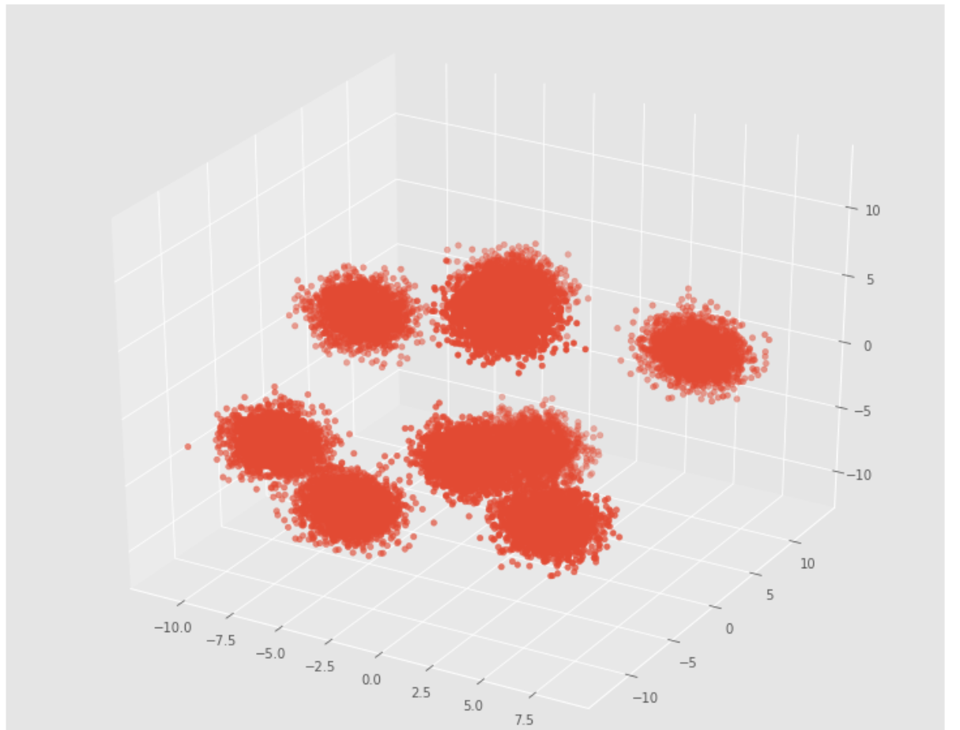

In [96]: 

*# Initializing KMeans*

kmeans **=** KMeans(n_clusters**=**5)

*# Fitting with inputs*

kmeans **=** kmeans.fit(X)

*# Predicting the clusters*

labels **=** kmeans.predict(X)

*# Getting the cluster centers*

C **=** kmeans.cluster_centers_

C

Out[97]:

array([[-2.11662986e+00, -8.68115769e+00, -4.31173051e+00, 6.67963995e+00, -4.32489287e+00, 4.08539729e+00,

-1.00496743e+00, -4.04598438e+00, -4.66583377e+00,

-5.54089195e-01, 4.79366686e+00, 2.45084516e+00,

-6.33107822e-01, 6.47012396e+00, -2.85497840e+00, 7.48780978e+00, -2.89950329e+00, -4.48614949e+00,

1.60276744e+00, -7.33902372e+00, 2.45827226e-01,

-1.06700274e+00, -6.11940909e-01, 2.46288221e+00,

-4.09258300e+00],

[ 1.52972804e-01, 7.76156845e+00, -1.62240869e+00,

-2.84969310e-01, -2.16645399e+00, 3.53919329e-01, 8.14015904e+00, -3.52788920e-03, 8.21409183e-01,

6.39890521e+00, -5.28296073e+00, 1.11244317e+00,

9.54035033e-01, 3.09461297e+00, 2.98482207e+00,

3.90281709e-01, 4.55691726e+00, 4.75728727e+00,

1.19142329e+00, -3.71171613e+00, -4.48806628e-01,

7.42226211e+00, -3.73692612e+00, -2.14356143e+00,

2.00060532e+00],

[ 2.70007075e+00, -7.34645066e+00, 9.47912842e+00,

-4.99390956e+00, 8.19877051e+00, -5.77024994e+00,

-9.58381480e-01, -2.09661172e+00, -4.95137149e+00,

-2.69801893e+00, -7.71075382e+00, -6.53697071e+00, 9.31663497e+00, 5.78838382e+00, -4.92993026e-01,

-9.15415298e+00, 8.19200108e+00, -9.78441045e+00,

-9.01931179e+00, -4.09833885e+00, 6.86111327e+00,

-2.43148350e-01, 8.45586457e+00, 8.59390989e+00,

-8.66331199e+00],

[-7.80733759e+00, 7.60495571e-01, 2.60277409e+00, 1.47727916e+00, -5.15093618e+00, -8.48828605e+00,

2.57012139e+00, -6.11357692e+00, 3.38973182e+00,

3.27485562e+00, -9.88805928e+00, -6.06451866e+00,

-6.81710875e+00, 1.93520022e-01, -5.93078179e+00, 1.70225836e+00, 1.50804324e+00, -8.99041567e+00,

1.83400964e+00, -7.33748593e+00, 7.26989946e-01,

-9.98797615e+00, -2.56075180e+00, -9.38973522e+00, 7.84706804e+00],

[ 1.50674055e+00, -8.04693763e+00, -9.65127874e-01,

-7.05675768e+00, 7.93162373e+00, 9.92436429e+00, 5.31864292e+00, -8.07273763e+00, -4.32119380e+00,

-8.28539390e+00, 7.59440341e+00, -3.30105462e+00,

-3.68258631e+00, 2.65738559e+00, -4.50556156e+00, 5.60250589e+00, -8.20269113e+00, 9.46359654e+00,

-4.47003939e+00, -9.14791399e-01, 1.37763257e+00, 5.74533954e+00, 6.05745607e+00, 2.53629442e+00,

3.30053898e+00]])

fig **=** plt.figure() ax **=** Axes3D(fig)

ax.scatter(X[:, 0], X[:, 1], X[:, 2],X[:,3] ,c**=**Y)

ax.scatter(C[:, 0], C[:, 1], C[:, 2],X[:,3], marker**=**'*', c**=**'#050505', s**=**1000)

C:\Users\Sid\AppData\Local\conda\conda\envs\image\lib\site-packages\mpl_tool kits\mplot3d\art3d.py:728: FutureWarning: elementwise comparison failed; ret urning scalar instead, but in the future will perform elementwise comparison

if zdir == 'x':

C:\Users\Sid\AppData\Local\conda\conda\envs\image\lib\site-packages\mpl_tool kits\mplot3d\art3d.py:730: FutureWarning: elementwise comparison failed; ret urning scalar instead, but in the future will perform elementwise comparison

elif zdir == 'y':

Out[98]:

<mpl_toolkits.mplot3d.art3d.Path3DCollection at 0x1f32c37da20>

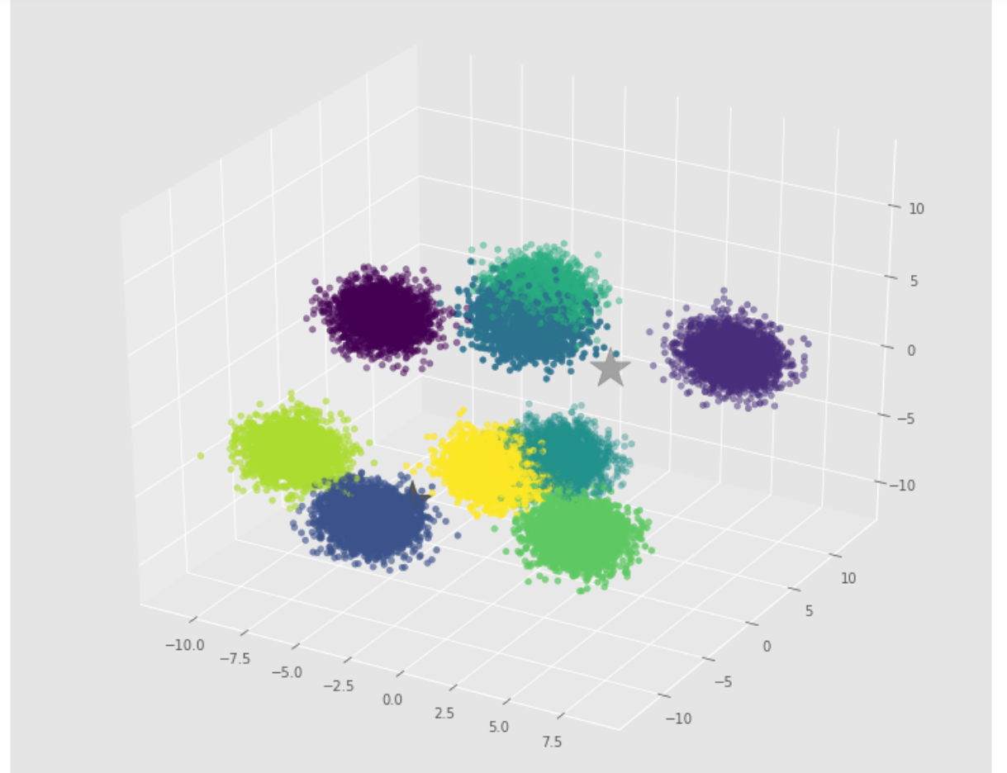

In [ ]: 